# Write a program to print your name, ID, and JEE rank/percentile using printf statements ONLY.

#include <stdio.h>

#include <stdlib.h>

int main()

{

printf("My Name Is : Shrey Sahay\n");

printf("My ID Is : B421047\n");

printf("My JEE Rank Is : 36531\n");

return 3;

}

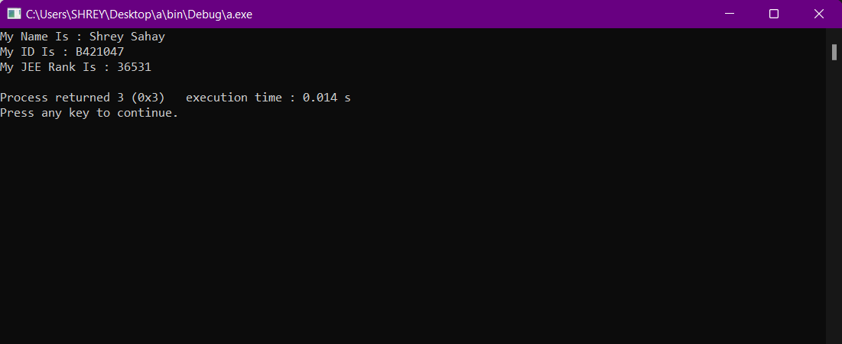

# Write a program to find the addition, subtraction, multiplication, and division of two FLOAT numbers

#include <stdio.h>

#include <stdlib.h>

int main()

{

float a,b;

//printf("Enter the value of a : ");

scanf("%f",&a);

//printf("Enter the value of b : ");

scanf("%f",&b);

float c,d,e,f;

c = a+b;

d = a-b;

e = a*b;

f = a/b;

printf("%f\n",c);

printf("%f\n",d);

printf("%f\n",e);

printf("%f\n",f);

return 3;

}

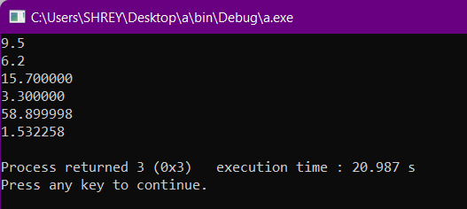

# Write a program to take salary as input, and calculate tax and PF deductions and find net savings after cutting expenditure.

#include <stdio.h>

#include <stdlib.h>

int main()

{

float s,it,pf,gs,ex,savings;

//printf("Enter your salary : ");

scanf("%f",&s);

it = 0.25*s;

pf = 0.20*s;

gs = s-it-pf;

ex = 0.30*gs;

savings = gs-ex;

printf("The net savings is : %f\n",savings);

return 3;

}

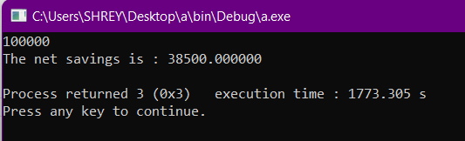

# Q4. Write a program to explore various functions of math.h header file – pow, sqrt, sin, cos, tan.

#include <stdio.h>

#include <stdlib.h>

#include <math.h>

int main()

{

printf("power(2,3) %f\n",pow(2,3));

printf("sqrt(3) %f\n",sqrt(3));

printf("sin(3) %f\n",sin(3));

printf("cos(3) %f\n",cos(3));

printf("tan(3) %f\n",tan(3));

return 3;

}

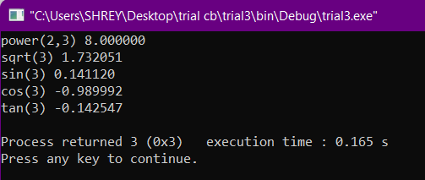

# Q5.Swap two numbers using a third variable.

#include <stdio.h>

#include <stdlib.h>

int main()

{

int a,b,c;

scanf("%d" "%d",&a,&b);

printf("Before swapping - ");

printf("%d ""%d\n",a,b);

c=a;

a=b;

b=c;

printf("After swapping - ");

printf("%d ""%d\n",a,b);

return 0;

}

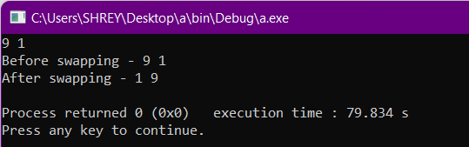

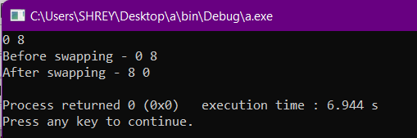

# Q6.Swap two numbers without using a third variable.

#include <stdio.h>

#include <stdlib.h>

int main()

{

int a,b;

scanf("%d" "%d",&a,&b);

printf("Before swapping - %d %d\n",a,b);

a=a+b;

b=a-b;

a=(a-b);

printf("After swapping - %d %d",a,b);

return 0;

}

